Internal Rhyme

🔹 What is Internal Rhyme
# Source: Chatgpt (GPT-4-turbo) at [8/2/2025]
⚠️ Internal rhyme is a type of poetic rhyme, not a formal category of homograph, but homographs can appear within internal rhymes if they match in sound.

✅ Definition of Internal Rhyme
# Source: Chatgpt (GPT-4-turbo) at [8/2/2025]
Internal rhyme occurs when words rhyme within a single line of poetry, or between internal words and line endings.
These rhymes do not have to appear at the end of lines—hence the term “internal.”

🧪 Types of Internal Rhyme
# Source: Chatgpt (GPT-4-turbo) at [8/2/2025]
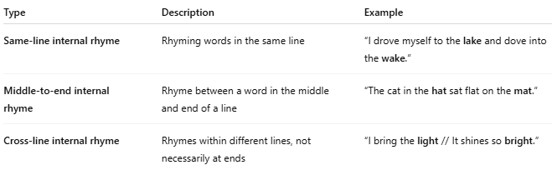
Type | Description | Example
Same-line internal rhyme | Rhyming words in the same line | “I drove myself to the lake and dove into the wake.”
Middle-to-end internal rhyme | Rhyme between a word in the middle and end of a line | “The cat in the hat sat flat on the mat.”
Cross-line internal rhyme | Rhymes within different lines, not necessarily at ends | “I bring the light // It shines so bright.”

📝 Examples of Internal Rhyme Using Homographs
# Source: Chatgpt (GPT-4-turbo) at [8/2/2025]
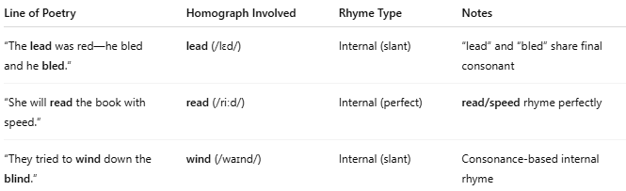
Line of Poetry | Homograph Involved | Rhyme Type | Notes
“The lead was red—he bled and he bled.” | lead (/lɛd/) | Internal (slant) | “lead” and “bled” share final consonant
“She will read the book with speed.” | read (/riːd/) | Internal (perfect) | read/speed rhyme perfectly
“They tried to wind down the blind.” | wind (/waɪnd/) | Internal (slant) | Consonance-based internal rhyme

🧭 Relationship Between Homographs and Internal Rhyme
# Source: Chatgpt (GPT-4-turbo) at [8/2/2025]
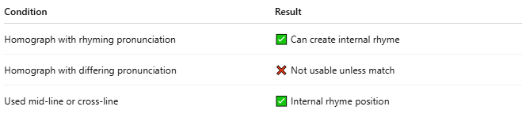
Condition | Result
Homograph with rhyming pronunciation | ✅ Can create internal rhyme
Homograph with differing pronunciation | ❌ Not usable unless match
Used mid-line or cross-line | ✅ Internal rhyme position

📊 Comparison Table
# Source: Chatgpt (GPT-4-turbo) at [8/2/2025]
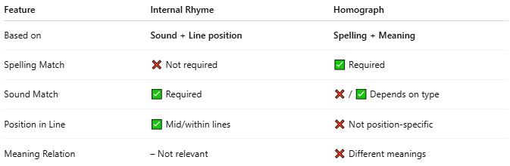
Feature | Internal Rhyme | Homograph
Based on | Sound + Line position | Spelling + Meaning
Spelling Match | ❌ Not required | ✅ Required
Sound Match | ✅ Required | ❌ / ✅ Depends on type
Position in Line | ✅ Mid/within lines | ❌ Not position-specific
Meaning Relation | – Not relevant | ❌ Different meanings

✅ Summary
# Source: Chatgpt (GPT-4-turbo) at [8/2/2025]
- Internal rhyme is a sound-based poetic technique.
- Homographs may participate in internal rhyme when:
  - They share pronunciation with another word in the line.
  - They appear within or across poetic lines.

